**7/7 edit**

**Need**

**LLC Names: ikigai, Parea, OurSport**

Name: FindRentPlay

Server= Firesbase, aws

Domain= Godaddy (done)

**Our payment gateway providers are Stripe, Authorize.net, and Paypal. A link to each provider (you may use multiple) is below. If your facility already has an account with any of those, you may skip this step.**

**Complete Rental Info Form**

**Create Payment Account**

**Complete the form below. Make sure to add all rentals spaces with corresponding individual rates and available times**

Features

* Review section
* Contact me to put up company or figure out a way to create a profile
  + Possibly later get a reservation through FRP instead of redirection
* Sort by sport
* Sort by location
* Sort by availability?

**Cost Initial**

* Domian: $1.99
* Host: $22.99 per month
* Theme and plugin: $80
* Theme: $69
* Plugin $29
* Page builder $49
* Ssl $54 yr
* Email $5.99/month
* Booking calendar: see commissary note
* y7gYsB52AjO17VqN0veKUIbQv16CrqoL
* **y7gYsB52AjO17VqN0veKUIbQv16CrqoL**
* [**https://www.findrentplay.com/privacy-2/**](https://www.findrentplay.com/privacy-2/)
* **https://www.findrentplay.com/wp-content/uploads/2020/06/privacy-1.pdf**

**ToDo**

**Change ALL spice level boxes in user dashboard**

**Create a how to enter payment account info doc**

**Create a how to import bookings doc**

**Change Payment plans to offer a monthly recurring or one time yearly fee**

**Change “menu” to “facility rentals” select plan page**

**Create a WHY join our site, bottom of homepage**

**Fix uploading images issue on listing submission form (check at office, could be upload speed) was a file size issue, limited to 2 MB for gallery uploads**

**Change Contact Owner Function to “Start a Contract”**

**Edit how to get started page**

**Create a How to page with FAQ and tutorials**

**How to make a deposit instead of full payment**

**Fix User Role Permission, allow to add post, pages, images, etc. Whatever fixes the facility rental overiew in dashboard.**

**Change dashboard Facility Rentals to Rentals and Free>> Type>>Sport**

**Fix edit facility rental overview spice level and popular item (just need to refresh page)**

**Need to find how to allow multiple image upload for create menu item(list-menu.php line 277)**

**Change “menu “ on listing Details page to “facility Rentals”**

**Put please wait if uploading several images, may take time**

**Images will be on banner of page (recommended)**

change the leads pop up in dashboard to mention buying ads

Fix “menu” in listing detail to say Rentals

**Eatablish LLC**

finish making privacy policy and attaching it

set up login with socials

**Change listing region placeholder**

Connect all pages to nav header

Privacy policy connection in footer

Fix all placeholder images

If doing pay per day then change only play when you click

Ian Brice hodge bank account

Save all receipts

Ad campaign dashboard contact number

Customize reviews

Get an image for how it works page

Change the placeholder text for “Submit a Review” in the listing detail page

Can we get booking function within user dashboard?

Issues: have to link button on each listing page to that user’s BC account form

A lot of customization for businesses.

Do I create the BC accounts and give the Facilities the login?

Would it be cheaper/better to amend LP appointment feature?

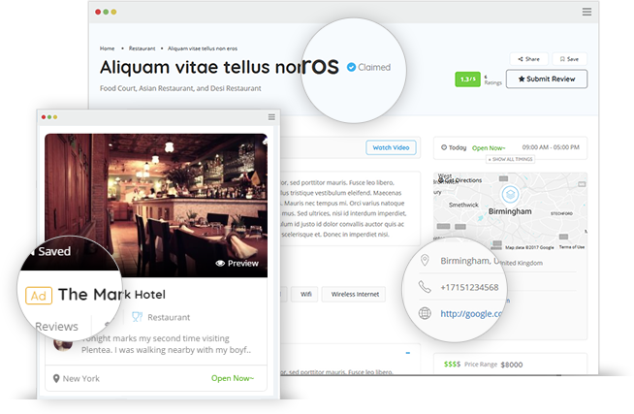

First year free/

3 Full Length Basket

Create account

Select Plan

Add Facility

Add Rental Spaces

Complete Rental Info Form

Create/Link Payment Accounts

**Find Your Plac**

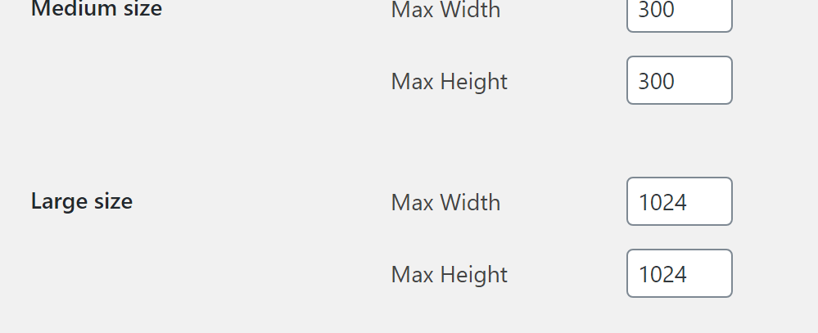

**e To Play Today**

FindTop of Form

Location

The php functionality is under class name “form-control”

Listing bottom banner : loop3.php

Select Plan Page:   
/public_html/wp-content/plugins/listingpro-plugin/templates/pricing/loop/horizontal_view_1.php

Individual Listing Pages : listing_detail3php

Opions for LP in WP: options.config.php

Submit Listing Form : public_html/wp-content/plugins/listingpro-plugin/elementor-widgets/submit-listing.php

Deleted select 2 from line 1362 & 1365 after class